**Python Data Type: List**

Name: Aleksandra Jaworska

Album no. : 162589

Group: WAW_2023_L_N_I_INF7_C4

Student email: [wwx19038@student.warszawa.merito.pl](mailto:wwx19038@student.warszawa.merito.pl)

GitHub link:

Structure of task presentation:

* The content of the task
* Theoretical issues
* Code
* Code result

1. Write a Python program to sum all the items in a list.

def sum_list(items):

sum_numbers = 0

for x in items:

sum_numbers += x

return sum_numbers

print(sum_list([-1, 9, -8]))

OUTCOME:

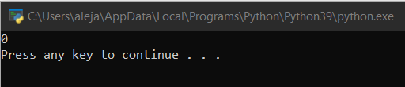

1. Write a Python program to multiply all the items in a list.

def multiply_list(items):

tot = 1

for x in items:

tot *= x

return tot

print(multiply_list([2, 2, -8]))

OUTCOME:

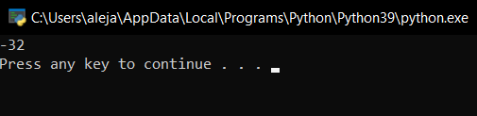

1. Write a Python program to get the largest number from a list.

def max_num_in_list(list):

max = list[0]

for a in list:

if a > max:

max = a

return max

print(max_num_in_list([1, 4, -11, 3]))

OUTCOME:

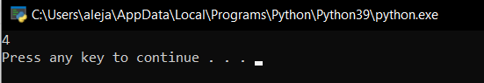

1. Write a Python program to get the smallest number from a list.

def smallest_num_in_list(list):

min = list[0]

for a in list:

if a < min:

min = a

return min

print(smallest_num_in_list([9, 5, -12, 0]))

OUTCOME:

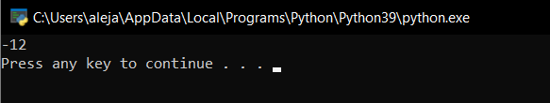

1. Write a Python program to count the number of strings from a given list of strings. The string length is 2 or more and the first and last characters are the same.

def match_words(words):

ctr = 0

for word in words:

if len(word) > 1 and word[0] == word[-1]:

ctr += 1

return ctr

print(match_words(['abcdef', 'xyzihj', 'aba', '1221']))

OUTCOME:

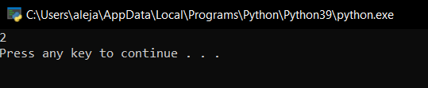

1. Write a Python program to remove duplicates from a list.

a = [10, 20, 30, 20, 10, 40, 60, 40, 90, 50, 40]

dup_items = set()

uniq_items = []

for x in a:

if x not in dup_items:

uniq_items.append(x)

dup_items.add(x)

print(dup_items)

OUTCOME:

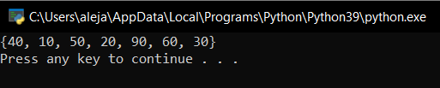

1. Write a Python program to check if a list is empty or not.

l = []

if not l:

print("List is empty")

OUTCOME:

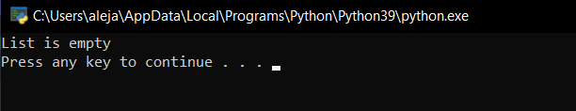

1. Write a Python program to clone or copy a list.

original_list = [11, 22, 33, 44, 55]

new_list = list(original_list)

print(original_list)

print(new_list)

OUTCOME:

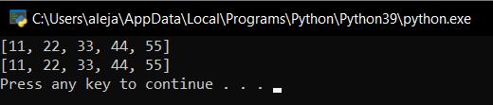

1. Write a Python program to find the list of words that are longer than n from a given list of words.

def long_words(n, str):

word_len = []

txt = str.split(" ")

for x in txt:

if len(x) > n:

word_len.append(x)

return word_len

print(long_words(4, "The little busy bee flies from flower to flower"))

OUTCOME:

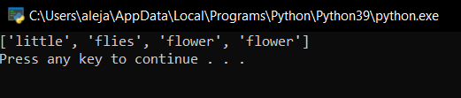

1. Write a Python function that takes two lists and returns True if they have at least one common member.

def common_data(list1, list2):

result = False

for x in list1:

for y in list2:

if x == y:

result = True

return result

print(common_data([1, 2, 3, 4, 5], [5, 6, 7, 8, 9]))

print(common_data([1, 2, 3, 4, 5], [6, 7, 8, 9]))

OUTCOME:

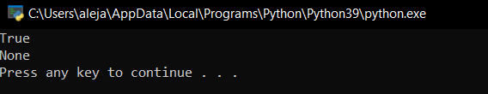

1. Write a Python program to generate a 3*4*6 3D array whose each element is *.

def common_data(list1, list2):

num = [3, 2, 246, 1024, 23, 69, 2037]

num = [x for x in num if x % 2 != 0]

print(num)

OUTCOME:

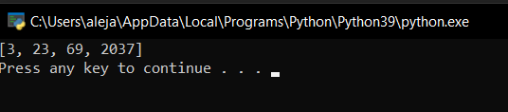

1. Write a Python program to generate and print a list of the first and last 5 elements where the values are square numbers between 1 and 30 (both included).

def printValues():

l = list()

for i in range(1,31):

l.append(i**2)

print(l[:6])

print(l[-6:])

printValues()

OUTCOME:

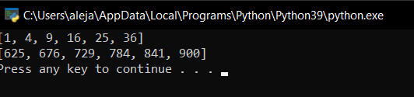

1. Write a Python program to calculate the difference between the two lists.

list1 = [1, 3, 5, 7, 9]

list2 = [0, 2, 4, 6, 7, 8, 9]

diff_list1_list2 = list(set(list1) - set(list2))

diff_list2_list1 = list(set(list2) - set(list1))

total_diff = diff_list1_list2 + diff_list2_list1

print(total_diff)

OUTCOME:

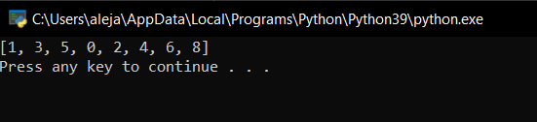

1. Generate all permutations of a list in Python

import itertools

print(list(itertools.permutations([2, 1, 3, 7])))

OUTCOME:

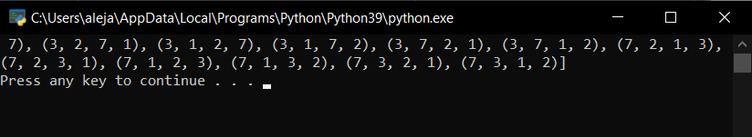

1. Write a Python program to access the index of a list.

nums = [0, 10, 35, 2, 234]

for num_index, num_val in enumerate(nums):

print(num_index, num_val)

OUTCOME:

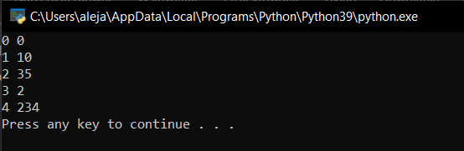

1. Select an item randomly from a list

from random import choice

def random_element(lst):

return choice(lst)

print(random_element([2, 3, 4, 7, 9, 11, 15]))

OUTCOME:

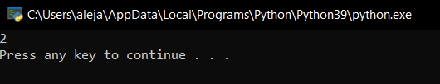

1. Write a Python program to print a list of space-separated elements.

num = [1, 2, 3, 4, 5]

print(*num)

OUTCOME:

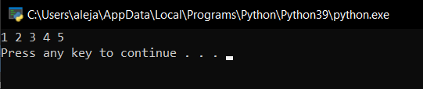

1. Write a Python program to find all the values in a list that are greater than a specified number.

list1 = [220, 330, 500]

list2 = [12, 17, 21]

print(all(x >= 200 for x in list1))

print(all(x >= 25 for x in list2))

OUTCOME:

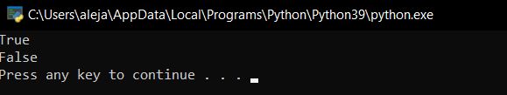

1. Write a Python program to remove empty lists from a given list of lists.

list1 = [[], [], [], 'Red', 'Green', [1, 2], 'Blue', [], []]

print("Original list:")

print(list1)

print("\nAfter deleting the empty lists from the said lists of lists")

list2 = [x for x in list1 if x]

print(list2)

OUTCOME:

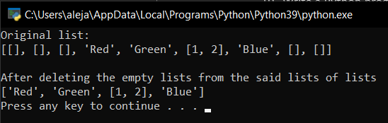

1. Write a Python program to find the maximum and minimum values of the three given lists.

nums1 = [2, 3, 5, 8, 7, 2, 3]

nums2 = [4, 3, 9, 0, 4, 3, 9]

nums3 = [2, 1, 5, 6, 5, 5, 4]

print("Original lists:")

print(nums1)

print(nums2)

print(nums3)

print("Maximum value of the said three lists:")

print(max(nums1 + nums2 + nums3))

print("Minimum value of the said three lists:")

print(min(nums1 + nums2 + nums3))

OUTCOME:

